Title: Coping with the Cone of Uncertainty: An Empirical Study of the SAIV Process Model
Author: Da Yang, Barry Boehm, Ye Yang, Qing Wang and Mingshu Li
Article Summary:
This research article written by major contributors to software engineering industry has focused on techniques to be used while coping up with uncertainty in software projects. Its been stated that uncertainty is inherent part of the project, and we need to deal with how can we come up with uncertainty while in the project and planning project. Authors in this paper explained all those mechanisms by considering 8 projects of University of Southern California students who were given real time clients projects for developing software and project to be completed within 24 weeks of assignment. These students in their project considering the techniques described by the authors successfully delivered clients stated requirements with satisfaction and appropriate planning. It is been said that estimation of cost been very accurate comes with prior experience, historical data of past projects, applying formal methods for estimation. Barry Boehm explained his theory with cone of uncertainties which states that as we go on further with our software development life cycle, the uncertainties lowers down, thus reducing the gap at certain point. Students at USC took certain approach and process models to deliver their projects on time such as Schedule as Individual Vehicle (SAIV), also used COCOMO II methodology, understanding requirements correctly from stakeholders, time scheduling, calculating efforts, iterative development i.e. developing project in phases. Also they allocated 12 weeks for development of Life Cycle Architecture (LCA) and remaining 12 weeks for Initial Operating Capability (IOC).SAIV process model with its element is described in detail in the article for readers to understand the cost estimation along with greater understanding of the other aspects of the project and handling with the uncertainties. It is always important in a project to deliver on time with customer satisfaction and incorporating all the core features with high priority and quality product.
Article Analysis:
This article address how project managers and people in industry can apply formal methods and estimation techniques to have real project and cost estimates and handle uncertainties. This research study explains USC students approach starting from making cost estimation, appropriate project planning, allocating resources, calculating risk, time management, along with on time delivery of project meeting customer expectations.
SAIV approach considers schedule as independent variable and lower priority features as dependent variable. Below Diagram (Figure 1) exhibits six elements of SAIV along with four features to cope up with uncertainty.
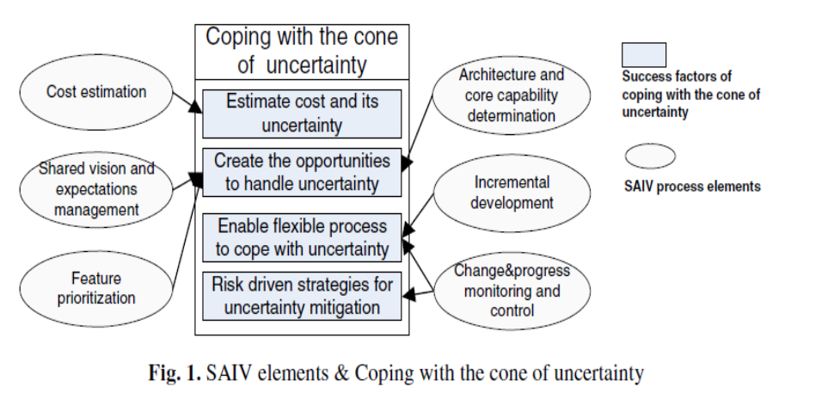
1. Estimate Cost and its uncertainty: Cost estimation (SAIV element) is the technique applied for handling with this uncertainty. Students calculated effort estimates from COCOMO II with some assumptions such as they will work 12 hours per week, 10 weeks will be for construction phase, remaining 2 weeks for transitional operations. Also divided effort estimations into 3 categories optimistic, pessimistic and most likely. In this way they calculated actual efforts, relative error which helped them in having an idea of what features can be delivered to stakeholders with the allocated time.
2. Create the opportunities to handle uncertainty: It is very important in a project to maintain and deliver client’s expectations which are promised. Don’t make false promises which leads to failure of delivering project on time with all user requirements. Feature prioritization helps in delivering the features with high priority (can’t afford to miss them) first. Students at USC classified Capability Requirement and Core Capabilities with Must, should, could, want features according to customer requirement for the product.
3.Enable Flexible Process: Developing project in iteration helps as in first iteration development and delivering of core capabilities will be done and in second iteration all lower priority features can be implemented. This help focusing and avoid deviation from fulfilling main objective .Alo project should be continuously monitored throughout development life cycle along with keeping track of changing requirements, integration with other software, resource allocation, effort estimations.
4. Risk Driven Strategies: There should always be document which should be ready before project starts which includes expected risk and mitigation techniques, risk management.
Author’s says that fulfillment of core capabilities should be done in first iteration, this increases success rate. With the help of linear regression graph it is stated that if many of the requirements are described as core requirements by stakeholders, it reduces chance to complete the core requirements in first iteration. Or it can also be said that the customer have too high expectations and we are unable to manage them.
Article Critique:
An excellent article written by pioneer of software industry. It is good article and I must say that every software engineer should read it at least once to have an idea on coping with uncertainties. Here are my personal critique as below:
Strengths:
- Authors approach to consider students project management techniques for real time client is appreciable.
- The paper is systematic which includes every detail for a reader to understand what they are intending too. Also the references the end helps in understanding any concept which is unclear to readers.
- Subject of the article goes very well with what authors aimed at. Introduced the concept of SAIV process and element and how these are used to cope up with uncertainty.
- Key Implications of the paper were at applying the SAIV elements in the project for uncertainties to have greater success ratio.
- Research Article very well presented in term of headings, structuring, formulas, diagrams and graphs, ending up with conclusion.
- Authors of this article have deep understanding and well versed with the topic, that’s the reason readers able to gain understanding of the practices to be used before a project starts.
- This paper will be extremely useful for students and upcoming professional for are ready to go in industry and apply these for their planning and project estimations.
Weakness:
- This paper includes technical terms therefore reader needs to look back into many references cited by the author at the end which sometime may annoy readers.
- Many of the information is taken from the other research paper or articles already published.
- Author could have made paper better by including some practices which people are using in current industry and should not use that.
- For through understanding of this paper, reader may have to read paper at least twice to gain clear understanding of it.

